Ministry of Higher Education | 
Pyramids High Institute for Engineering and Technology

Electronics and Communication Department

PHI Graduation Project

Project Title

Prepared by

Abdelrahman Shrief | 20200
Asmaa Mohamed | 20200
Mahmoud Gaballah | 20200
Mo′men Mohamed | 20200
Mohamed Alaa | 20200
Mohamed Hossam | 20200
Mohamed Nageh | 20200
Sondos Reda | 20200

Supervisor

Dr. Gamal El-Sheikh

PHI 2025

Introduction about Self-driving
Nowadays, the majority of vehicles have been converted to digital form. Offer the driver improved ease of use and enhanced data, including up-to-the-minute traffic updates, performance stats evaluation of information similar to velocity, and playing audio online. Cloud computing, among other advancements, has made cars today highly technologically advanced, and there is a lot more yet to happen. Tomorrow's car will transform the automotive industry. Be a significant improvement from what is currently available. Self-driving or autonomous vehicles have become prevalent. a long-cherished aspiration—a dream that has consistently been unsuccessful—come into existence. Self-driving vehicles are now a reality. A piece of fiction within the science genre. A highly specific and specialized In the market, the autonomous car sector is progressing quickly. Progress in incorporating numerous technologies from various sources Developing a self-driving car requires a complex ecosystem. To begin with, what exactly are autonomous vehicles? Per the information provided According to the National Highway Safety Administration (NHTSA), self-driving vehicles are cars capable of driving on their own without human assistance. No human intervention is necessary to steer. Increasing speed and reducing speed. The definition above suggests self-driving vehicles equipped with autonomous technologies. Allow the vehicle to travel from Point A to Point B by executing all necessary features needed for a vehicle to operate safely without any passengers inside. Despite the prevailing notion, driverless vehicles are considered a futuristic idea. Competition has commenced to introduce these vehicles onto our streets. These vehicles are causing a disturbance of unprecedented scale and reach.
Self-driving Levels
- Level 0 : No-Automation
At the ‘no-automation’ level, the driver is entirely responsible for the vehicle and its control system (brake, steering, motive power, navigation) at all times.
- Level 1 : Function Specific Automation
Automation at the ‘function-specific level’ involves automation for a few, i.e., one or two specific control functions. Automation at this level includes electronic stability control or pre-charged brakes. In such a situation, automation feature in vehicles assists with braking while the driver regains control of the vehicle.
- Level 2 : Combined Function Automation
Level 2, ‘combined automation function’, involves the automation of two primary control functions designed to work together. An example at this level could be enabling adaptive cruise control in combination with lane centering.
- Level 3 : Limited Self Driving Automation
In this level of automation, vehicles have full control over all safety-critical functions under different traffic or environmental conditions, and in those conditions, they rely heavily on the vehicle to monitor the complete driving process. The driver is also needed for occasional control, but with a sufficiently comfortable transition time.
- Level 4 : Full Self Driving Automation
At the final level of automation, the vehicle is designed to perform all functions of driving by itself. The car will be able to perform all safety-critical driving functions and monitor roadway conditions for an entire trip. In such a design, the driver or passenger will only have to input the destination in the car and will not need to control the vehicle at any time during the trip.
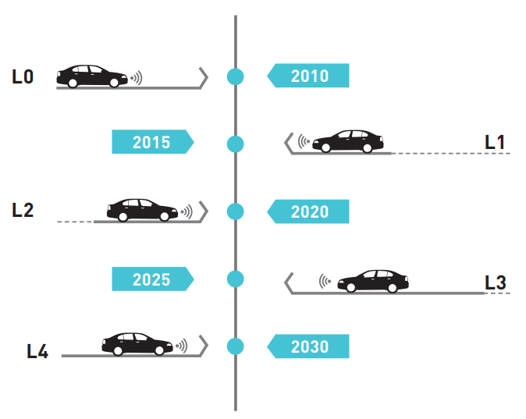
SOURCE: UN World Urbanization Prospects
Figure 1.1 Connected and Autonomous Vehicle Technology Road Map

